**User:**

The energy harvesting device is planned to be deployed in a coastal urban environment in Australia. The design needs to take into account the city where it will be applied to ensure consistent energy output throughout the year. Installation must be straightforward. In terms of maintenance, the unit should be designed to minimise the need for frequent repairs and, where necessary, key components should be easily accessible.

Based on the above background, I will be designing an energy harvesting device.

The energy harvesting device shall require three key modules:

1. The energy accumulation module functions to derive energy from an external source outside the energy harvesting device.

2. The energy storage module functions to store the accumulated energy inside the energy

harvesting device.

3. The energy utilization module utilizes the harvested energy to power other small devices such as sensors, heating/cooling devices, actuators, and low-power devices.

Please give me as many and reasonable and complete designs as possible.

**GPT:**

Designing an energy harvesting device for a coastal urban environment in Australia, especially one that is efficient, low-maintenance, and straightforward to install, is a complex but intriguing challenge. Given your requirements, I'll outline a few design concepts that incorporate the three key modules you've mentioned: energy accumulation, energy storage, and energy utilization.

Design 1: Solar-Wind Hybrid System

Energy Accumulation Module: Utilize both solar panels and small wind turbines. Solar panels can be efficient in sunny conditions, while wind turbines can harness energy during less sunny periods, typical in coastal environments.

Energy Storage Module: Implement advanced lithium-ion batteries or supercapacitors for energy storage. These can efficiently store energy from both solar and wind sources.

Energy Utilization Module: Use a smart management system to distribute power to the connected devices, prioritizing based on energy availability and device necessity.

Design 2: Piezoelectric Energy Harvester

Energy Accumulation Module: Use piezoelectric materials that generate energy from mechanical stress, such as vibrations from city infrastructure (e.g., bridges, roads).

Energy Storage Module: Smaller scale batteries or supercapacitors, as the energy generation might be less consistent than solar or wind.

Energy Utilization Module: Ideal for powering small sensors in the urban environment, particularly useful for structural health monitoring of buildings and infrastructure.

Design 3: Tidal & Wave Energy Harvester

Energy Accumulation Module: Given the coastal setting, harnessing tidal and wave energy could be very effective. Use floating buoys or underwater turbines to capture this energy.

Energy Storage Module: Larger scale energy storage systems to accommodate the higher energy yield from tidal forces.

Energy Utilization Module: Could support more significant power needs, such as street lighting or emergency communication systems.

Design 4: Thermoelectric Generators

Energy Accumulation Module: Capture energy from temperature differentials, such as those found between the air and water in coastal areas.

Energy Storage Module: Standard battery storage, as the energy generation would be relatively low.

Energy Utilization Module: Ideal for low-power devices like sensors, especially in areas with significant temperature differences.

Design 5: Bioenergy from Algae

Energy Accumulation Module: Utilize algae bioreactors to produce bioenergy through photosynthesis.

Energy Storage Module: Store the bioenergy as biofuel which can be burned to generate electricity when needed.

Energy Utilization Module: More suitable for larger-scale applications, like supplementing the power grid or powering larger installations.

Maintenance and Installation Considerations

For all designs, use modular components for easy replacement.

Regular but simple maintenance tasks, such as cleaning solar panels or checking battery health.

Installation should be designed for urban settings, considering space constraints and environmental impact.

Each of these designs has its unique advantages and challenges, and the best choice would depend on the specific conditions and requirements of the location in Australia where the device will be deployed. Remember, the effectiveness of these designs would be influenced by local environmental conditions, available space, and specific energy needs.

**User:**

Based on the design 1 you gave me above, please generate a visual concept diagram.

**GPT:**

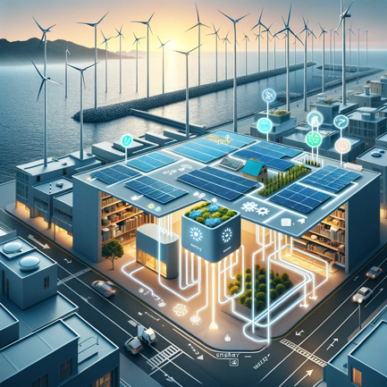

Here is the visual concept diagram for Design 1, which features an energy harvesting system designed for a coastal urban environment in Australia. This system incorporates a hybrid of solar panels and wind turbines to harness renewable energy.

**User:**

Based on the design 2 you gave me above, please generate a visual concept diagram.

**GPT:**

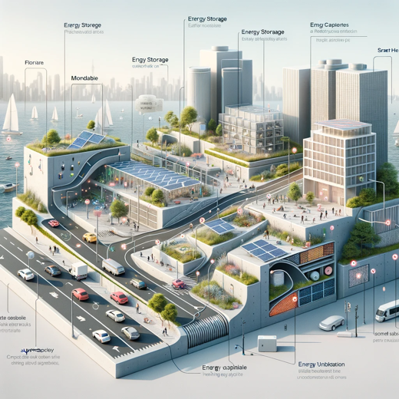

Here is the visual concept diagram for Design 2, showcasing a piezoelectric energy harvesting system for an urban coastal setting.

**User:**

Based on the design 3 you gave me above, please generate a visual concept diagram.

**GPT:**

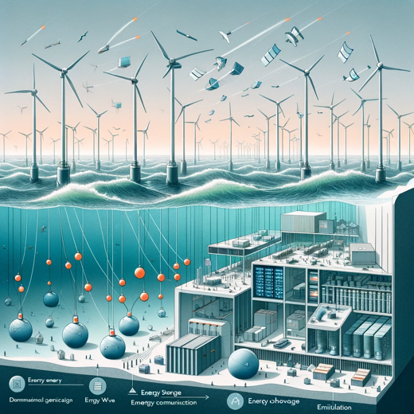

Here is the visual concept diagram for Design 3, featuring a tidal and wave energy harvesting system for a coastal urban environment.

**User:**

Based on the design 4 you gave me above, please generate a visual concept diagram.

**GPT:**

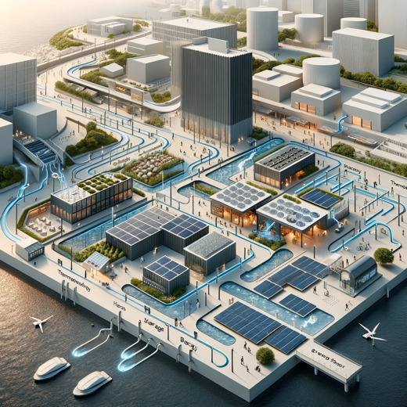

Here is the visual concept diagram for Design 4, illustrating a thermoelectric energy harvesting system in a coastal urban setting.

**User:**

Based on the design 5 you gave me above, please generate a visual concept diagram.

**GPT:**

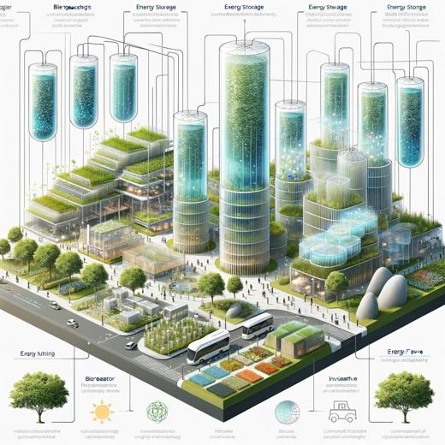

Here is the visual concept diagram for Design 5, which features a bioenergy harvesting system using algae in a coastal urban environment.